**Low-Level Design Document Rapido Application**

**App Flow Diagram:**

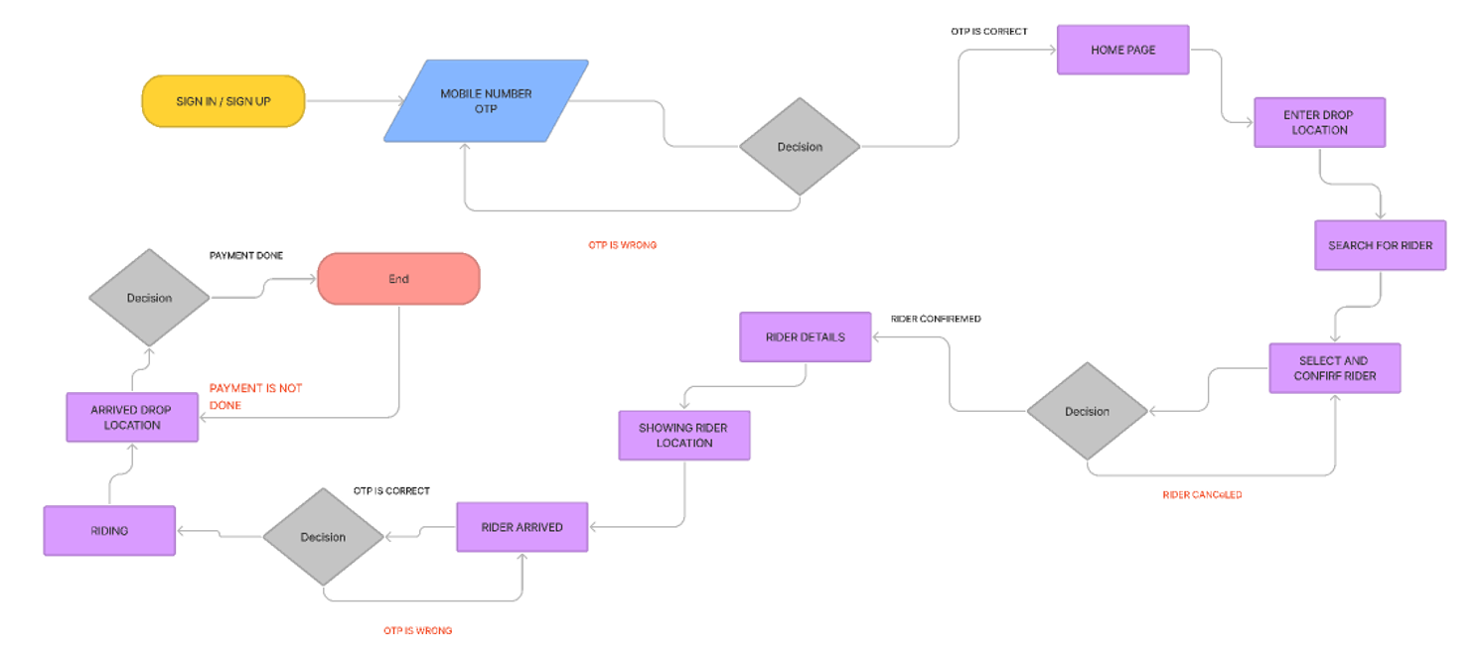

1. User Registration and Authentication Module:

* **Functionality:**
  + Allow users to register on the app using their mobile number or email address.
  + Implement OTP (One-Time Password) authentication for account verification.
  + Store user credentials securely in the database.
* **Components:**
  + Registration Form UI
  + OTP Generation and Verification Service
  + User Data Storage (Database)

2. Ride Booking Module:

* **Functionality:**
  + Enable users to book a ride by specifying pickup and drop-off locations.
  + Fetch nearby bikes using GPS location services.
  + Display estimated time and fare for the ride.
  + Allow users to confirm the booking.
* **Components:**
  + Ride Booking UI
  + Location Tracking Service
  + Fare Calculation Service
  + Ride Confirmation Handler

3. Real-Time Tracking Module:

* **Functionality:**
  + Track the location of the assigned bike in real-time.
  + Display the bike's current location and route on the user's map interface.
  + Update the estimated time of arrival based on real-time data.
* **Components:**
  + Real-Time Location Tracker
  + Map Integration Service (e.g., Google Maps API)
  + ETA (Estimated Time of Arrival) Updater

4. Payment Integration Module:

* **Functionality:**
  + Integrate with third-party payment gateways for secure transactions.
  + Support multiple payment methods such as credit/debit cards, digital wallets, etc.
  + Handle payment processing and transaction confirmation.
* **Components:**
  + Payment Gateway Integration Service
  + Payment Processing Handler
  + Transaction Confirmation Service

5. Feedback and Ratings Module:

* **Functionality:**
  + Allow users to provide feedback and ratings after completing a ride.
  + Store feedback data for analysis and improvement purposes.
  + Display average ratings for riders to help users make informed decisions.
* **Components:**
  + Feedback Submission UI
  + Feedback Data Storage
  + Rating Calculation Service

6. Customer Support Module:

* **Functionality:**
  + Provide multiple channels for customer support, such as in-app chat, email, or phone.
  + Handle user queries and issues related to rides, payments, etc.
  + Ensure timely resolution of customer support tickets.
* **Components:**
  + In-App Chat Interface
  + Email/Phone Support Handler
  + Ticket Resolution System

7. Security Measures:

* **Functionality:**
  + Implement SSL/TLS encryption for secure communication.
  + Hash and salt user passwords before storing them in the database.
  + Use OAuth or similar protocols for third-party integrations to protect user data.
* **Components:**
  + Encryption and Decryption Services
  + Password Hashing and Salting
  + OAuth Integration

8. Technology Stack:

* **Platform:** Android (Java), iOS (Swift)
* **Backend:** Node.js with Express.js
* **Database:** MongoDB
* **Payment Integration:** Stripe API
* **Real-Time Tracking:** Google Maps API

9. Future Enhancements:

* **Multi-Language Support:** Implement support for multiple languages to cater to a diverse user base.
* **Intelligent Routing:** Use machine learning algorithms to optimize route selection and reduce ride durations.
* **Public Transport Integration:** Integrate with public transport systems for seamless intermodal transportation options.
* **Promotions and Discounts:** Offer promotional deals and discounts to attract more users and encourage repeat usage.

Conclusion:

The Rapido application aims to provide users with a convenient and reliable bike taxi service. Through its various modules and components, it ensures a seamless experience for booking rides, tracking locations, making payments, and accessing customer support. With continuous improvements and future enhancements, Rapido strives to enhance the overall transportation experience for its users.